**59.1. Spring REST - Retrieve POJOs as JSON – Overview**

Here we will create a Spring rest service for students.

**Create a new service**:

* Return a list of students
* **GET** /api/students => Returns a list of students

**Spring REST Service**:

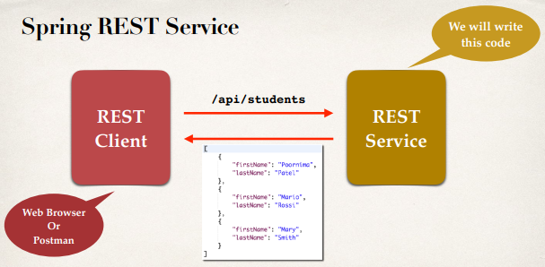

**Convert Java POJO to JSON**:

* Our REST Service will return **List<Student>**
* Need to convert **List<Student>** to JSON
* **Jackson** can help us out with this …

**Spring and Jackson Support**:

* Spring will automatically handle **Jackson** integration
* As long as the **Jackson** project is on the class-path or pom.xml
* JSON data being passed to REST controller is converted to Java POJO
* Java POJO being returned from REST controller is converted to JSON
* This all happens automatically behind the scenes

**Student POJO (class)**:

**public** **class** Student {

**private** String firstName;

**private** String laseName;

**public** Student() {

}

**public** Student(String firstName, String laseName) {

**this**.firstName = firstName;

**this**.laseName = laseName;

}

**public** String getFirstName() {

**return** firstName;

}

**public** **void** setFirstName(String firstName) {

**this**.firstName = firstName;

}

**public** String getLaseName() {

**return** laseName;

}

**public** **void** setLaseName(String laseName) {

**this**.laseName = laseName;

}

}

**Diagram**:

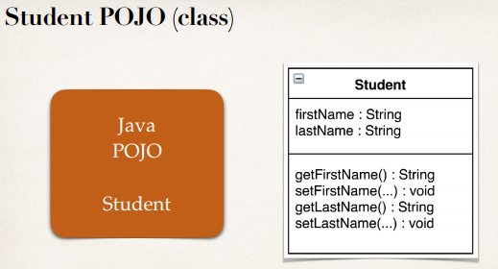

**Jackson Data Binding**:

* Jackson will call appropriate getter/setter method for the conversion.
* For JSON to Java POJO Jackson call setter method.
* For Java POJO to JSON Jackson call getter method.

Jackson doing all the works automatically for us behind the scenes.

**Diagram**:

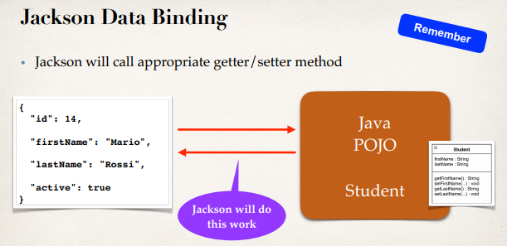

**Spring REST Service**:

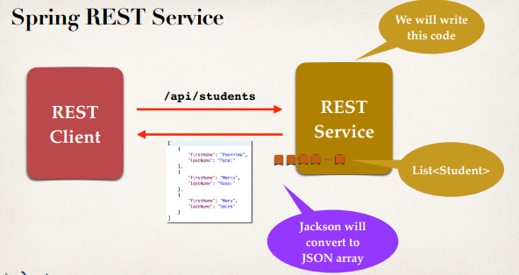

**Behind the scenes**:

* REST client sends a request to REST service thug "**/api/students**".
* Spring REST with Jackson works the middle of Clint and Server.
* When request comes to Server thug end-points REST service will create a list of students.
* Then the list will return to the client.
* Before that in the middle Jackson will convert the list into JSON array.
* JSON will use the appropriate getter/setter method to convert Java POJO to JSON.

**Diagram**:

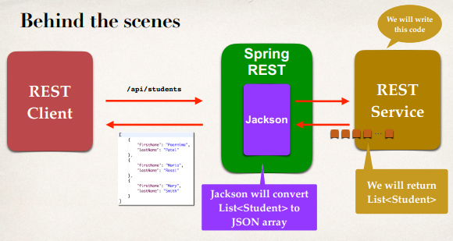

59.1. Spring REST - Retrieve POJOs as JSON - Overview